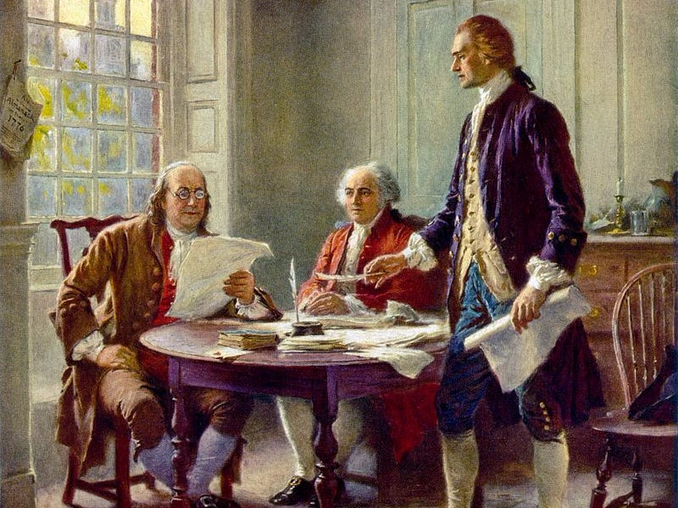
Thomas Jefferson (Right) authored the Declaration of Independence. Ben Franklin (left) and John Adams (middles) edited his final version. Jefferson was furious at their changes and nearly demanded his name be removed.

In 1775 the American colonies took up arms against the King’s Men in what became the American Revolution. We know the dispute began over unjust taxation and escalated into armed resistance. The Continental Congress was divided on how to resolve the issues with the King and Parliament, yet militiamen in Massachusetts were not interested in waiting for Congressional resolutions and fired on Redcoats igniting the battles of Lexington and Concord.

By the winter of 1776, it became readily apparent that rapprochement or resolving of issues, was not a reasonable possibility. With that, Congress moved to formally separate from the Mother Country to create a new nation. The first step in doing this was to properly declare independence. The Continental Congress chose Thomas Jefferson, a delegate from Virginia to write the Declaration of Independence.

Why did the chose him to write it? Jefferson was a brilliant wordsmith for one. John Adams stated Jefferson was the best writer of all of them. He was a Virginian, and this was not a trivial fact. Virginia was the largest and most powerful of all the colonies. Many in Congress believed that the colonists would be apt to follow Virginia’s lead. Further, Virginia was geographically near the middle of the thirteen colonies. It’s sphere of influence extended to the southern and northern colonies. In other words, about a third or more Americans did not want to separate from England (these folks were known as Loyalists) and the feeling was that if Virginia led the movement to separate Loyalists would be swayed to the cause.

Perhaps the most important reason Jefferson was selected to pen the Declaration of Independence was his knowledge of political philosophy. He was incredibly curious and studious about the history of political thought. Thomas Jefferson had an entire library of governmental and political works (later donated to the US Congress to become the Library of Congress) and had spent his adult life reading and researching law and politics. His biggest influence was British Philosopher, John Locke. In simple terms, Locke wrote that rights do not come from the government, they come from nature. A government cannot give one his or her rights because it is not theirs to give. We are all born with Natural Rights, rights that come from nature. Think of it as being born with our legs and hands. Our limbs are not given to us by the government, but by nature and the government cannot take them from us. According to Locke, every person is born with the right to life, the right to liberty and the right to property. Natural Rights:
The Right to Life: Meaning our lives are ours, we can live them as we choose and they and cannot be taken from us without cause.
The Right to Liberty: Meaning we can live our lives freely for as long as we are not impacting others.
The Right to Property: Meaning our lawfully acquired possessions are ours and cannot be taken from us without cause.

Finally, Locke argued that the government, any government, King, Queen, Senate, Parliament, Pharaoh, Emperor etc., has one job and only one job. That job is to protect our natural rights (protect being a key word, not give, but protect). We establish a government to protect our natural rights and that is the only thing a government should do. He continued to argue that when a government fails to do its job it is the obligation of the citizen to remove that government, even with violent means if necessary, and replace it with another government.

Jefferson was heavily influenced by John Locke when he wrote the Declaration of Independence. By and large, his position was the King of England was not protecting the natural rights of the American colonists, thus, as per John Locke, a British philosopher, the Americans were within their moral rights to violently remove themselves from the yoke of the British Government. On July 4th, 1776, Congress officially ratified and announced the Declaration of Independence and henceforth the colonies became states: The United States of America.

Task I.
Short and simple this week. Jefferson outlined a series of forty or so grievances or examples where King George, III (He) failed to protect the natural rights of the Americans. Simply put, The Declaration of Independence was a break-up letter in which Jefferson told the king, we are breaking up and here are all the reasons why.

In the Experience History textbook appendix, A-1-A-2 is the text of The Declaration of Independence. Pick any two grievances, type them word for word and then in your own words explain what they mean. These are worth two points each.

Task II.
This is an opinion based question and you will not lose or gain points based on how I agree or disagree with your opinion: Thomas Jefferson wrote the Declaration of Independence, was a key member of the Continental Congress, was an important figure in drafting the US Constitution, was the first Secretary of State and was the Third President of The United States. He wrote the Virginia State Constitution, established the University of Virginia, purchased the Louisiana Territory that more than doubled the size of the nation and as noted, donated his library to the American public. Thomas Jefferson owned over two hundred slaves and had more than a few illegitimate children with his slaves. Not only did Jefferson own slaves, he was a vocal advocate for protecting the institution of slavery in The United States, wrote about the “inferiority of the negro” and was a particularly cruel slave owner.

The question is, today we are seeing some folks tear down statues of Thomas Jefferson or argue we should remove these statues and not celebrate a slave owner. Others make the case that Jefferson was certainly a flawed human being, as are all of us, and we should not use today’’s morality to judge those from the past: At the at the time, slavery was commonly accepted, and we should honor him for his contribution to American History. Simply put, should we remove statues of Thomas Jefferson from pubic areas or should we leave them? Explain your position. (two points)

This is due via Blackboard Course Email Messages Wednesday July, 7th at 11:59 PM.

